

Cookbook Application

User Guide



April 2, 2015

CEN 4010 – software Engineering 1

L. Martin, D. Romero, M. Saunders, D. Young

Table of Contents

1 Introduction 2

1.1 Purpose 2

1.2 Scope 2

1.3 Overview 2

2 General Functionality 3

2.1 Register User (if unregistered) 3

2.2 Search 3

3 For Registered Users 4

3.1 Login 4

3.2 Create Cookbook 4

3.3 Create Recipe 5

3.4 Create Ingredient 5

3.5 Add Ingredients to Recipe 5

3.6 Add Recipe to Cookbook 6

3.7 Modify Recipe 6

4 For Administrator Users 8

4.1 Modify Ingredients 8

4.2 Modify Recipe 8

# Introduction

## Purpose

This document serves as a user guide to the Cookbook application. It is written for any user intending to use this application. This document describes, in detail, all functionalities of the Cookbook application

## Scope

This document describes all functionalities of the Cookbook application. This application will allow users to register accounts and create cookbooks for storing collections of recipes. The recipes are created by a particular user but can be viewed and shared by all users via the search functionality.

This application does not involve any social networking capabilities past seeing other user’s recipes. The application requires access to the web server it is running on, and is not available on any mobile specific platforms. It is accessible via a web browser only on all devices.

The benefits of this application include learning new recipes, sharing your favorite recipes, and organizing your recipes. In this way, the application aims to promote the sharing of recipe information.

## Overview

This analysis documents contains three sections: General Functionality, For Registered Users, and Administrator Functions.

The introduction contains the purpose of this document, its scope, and the overview describing what is contained in this document and how it is organized.

The ‘General Functionality’ section contains all functionality the Cookbook application makes available to any user, whether registered, unregistered, or administrator, including registering an unregistered user and the search function. The ‘For Registered Users’ section contains all functionality available to registered users (members). This includes Login, Create Cookbook, Create Recipe, Create Ingredient, Add Ingredients to Recipe, Add Recipe to Cookbook, Modify Recipe, and Modify Ingredients. The ‘For Administrator Users’ section contains functionality only available to administrators. This includes Modify Recipe.

# General Functionality

## Register User (if unregistered)

Normal Course

1. User selects to “Register”
2. Information is collected from the user: username, password, email
3. Information is tested for veracity
4. User account is created with supplied credentials
5. Welcome email is sent to the supplied address

Exceptions

Cancel Registration

1. The user selects cancel button at any time during the registration process
2. The system discards the temporary data and returns the user to the homepage

Username Already Exists

1. The user tries to register a username that already exists in the system
2. The system alerts the user and prompts if they want to change the username
3. The user cancels or enters a new username
4. The system cancels the registration or continues the registration

## Search

Normal Course

* + - 1. The System displays a search bar on all pages

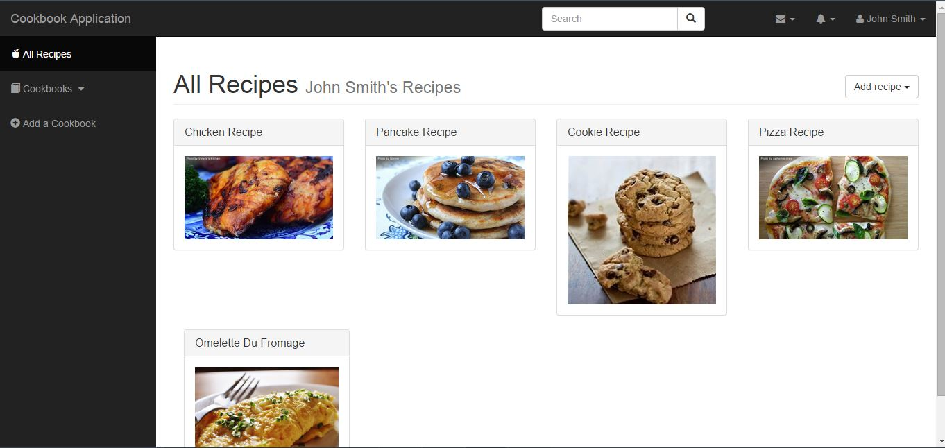

* + - 1. The user inputs the recipe or other keywords in the search bar

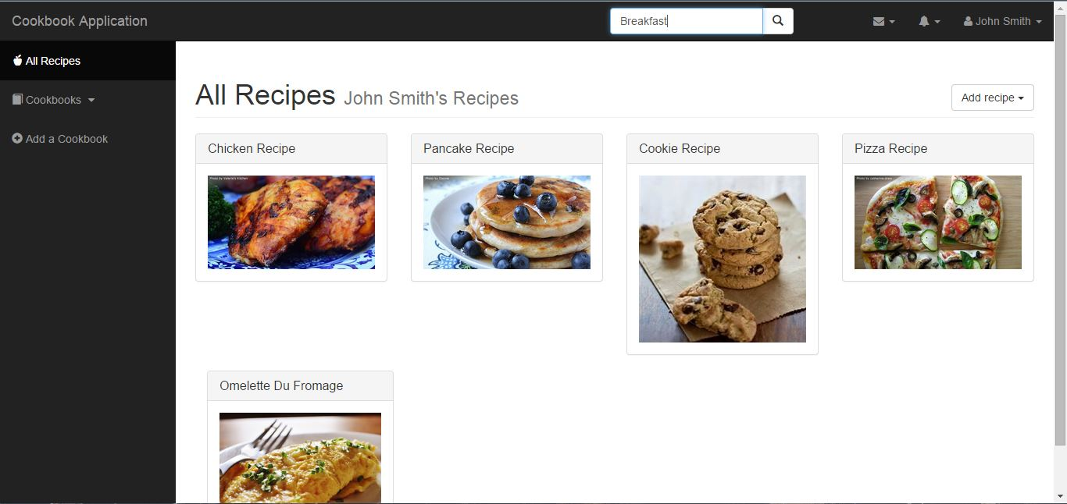

* + - 1. The system returns a list of search results that match keywords in the query

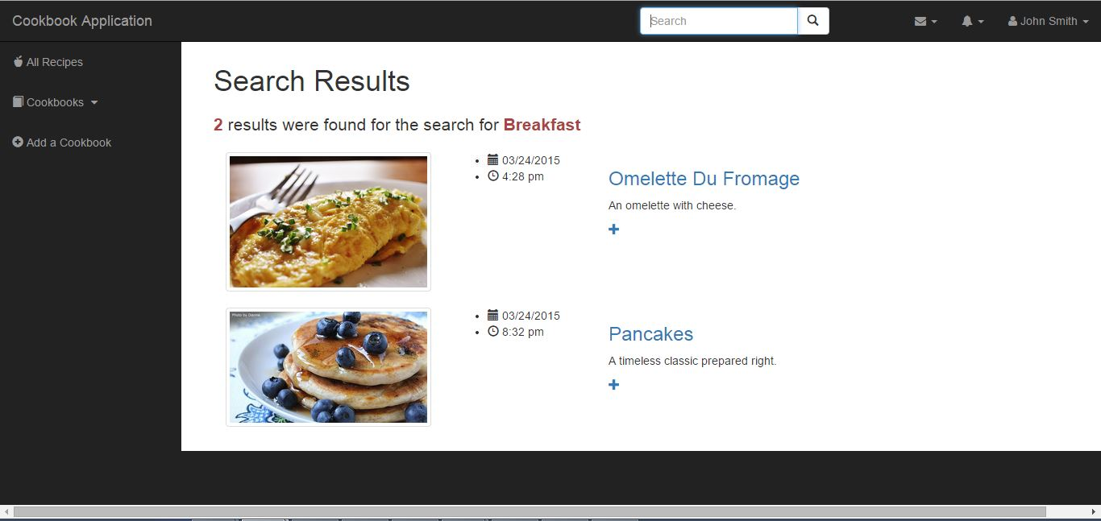

* + - 1. User interacts with search results, selecting those which best fit query

Exceptions

No results found

User attempts to search for recipes



The system fails to make a match and notifies the user.

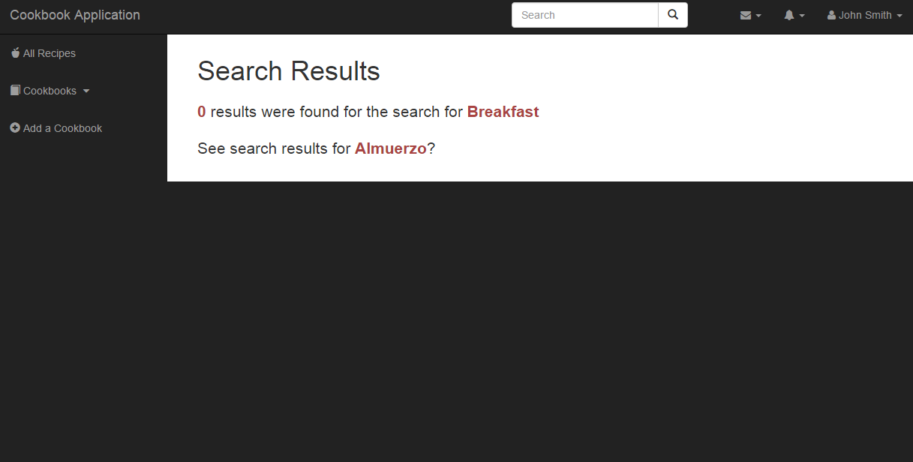

# For Registered Users

## Login

Normal Course

1. User selects to “Login”

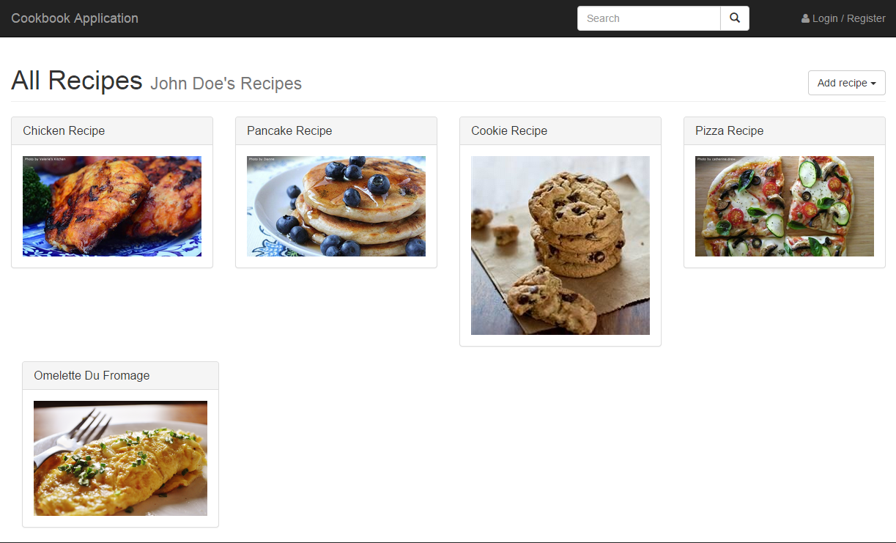

1. User is presented with a login screen

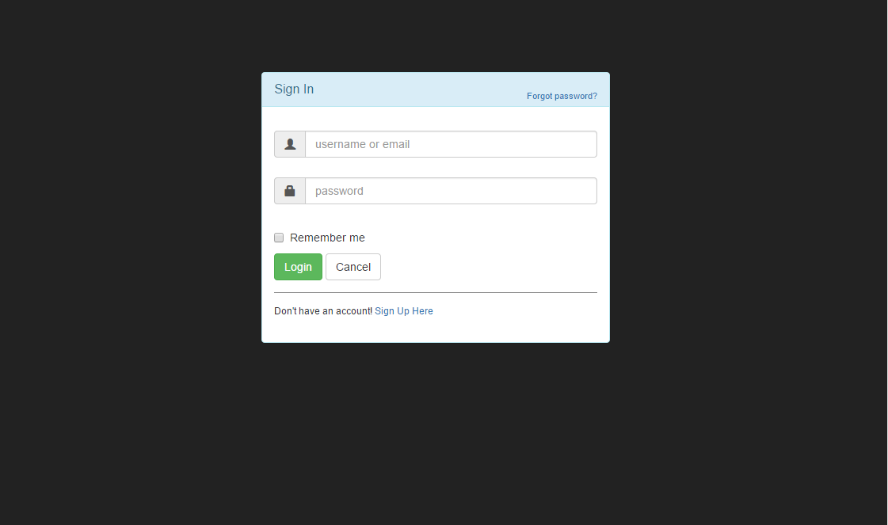

1. User enters their credentials

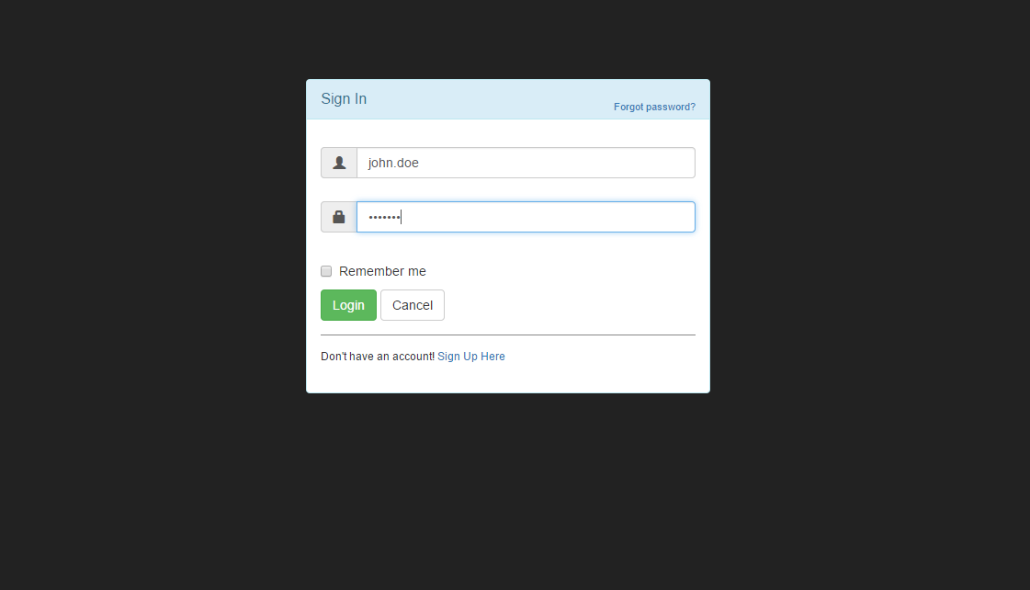

1. User selects login and the supplied credentials are verified. Upon success, the user is presented their home screen.

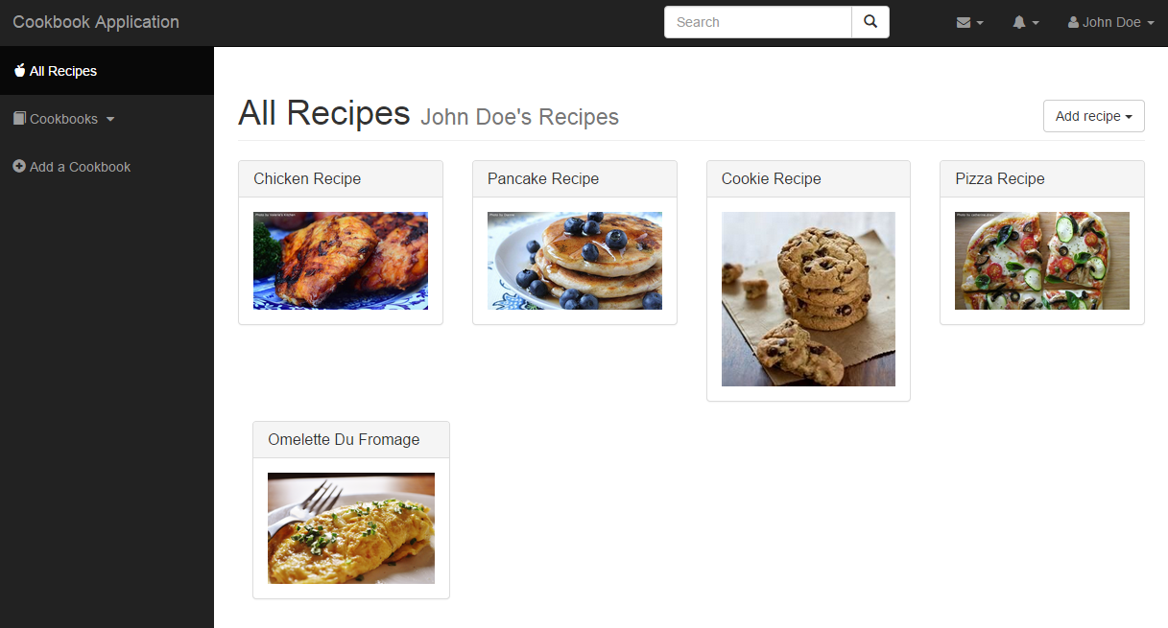

Exceptions

Cancel Login

1. The user selects cancel button at any time during the login process

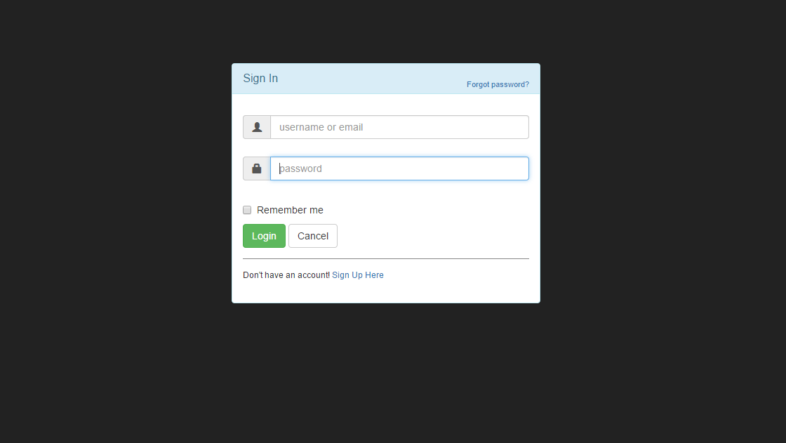

1. The system discards the temporary data and returns the user to the homepage

Username Does not exist

1. The user tries to login with a username that does not exist in the system

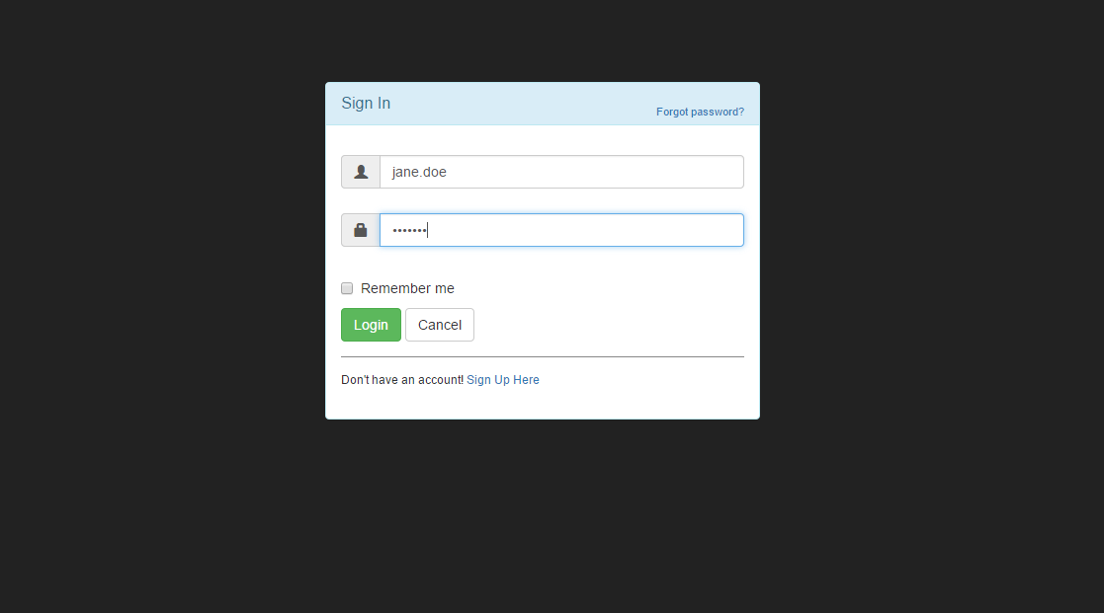

1. The system alerts the user and prompts if they want to change the username

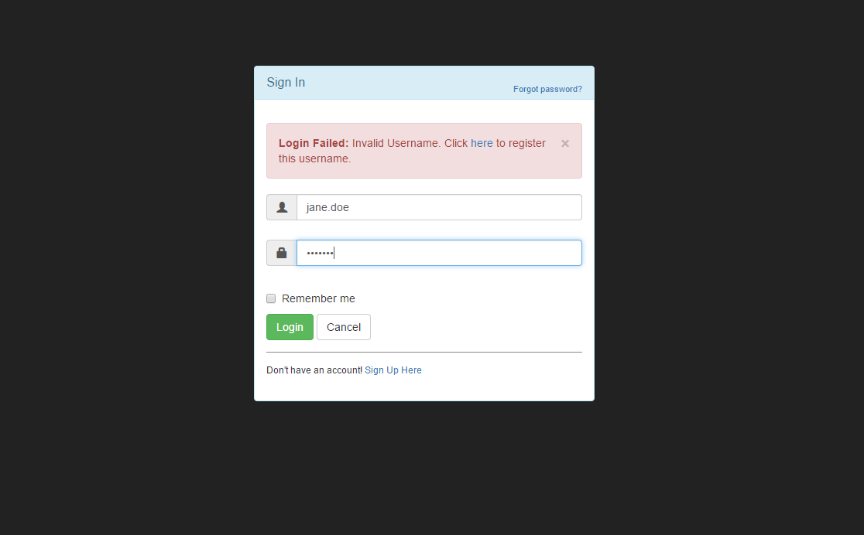

1. The user registers that username or enters a new username
2. The system cancels the registration or continues the registration

Password does not match the username

1. The user tries to login with a password that does not match the username
2. The user is alerted to the error and prompted to re-try the login.

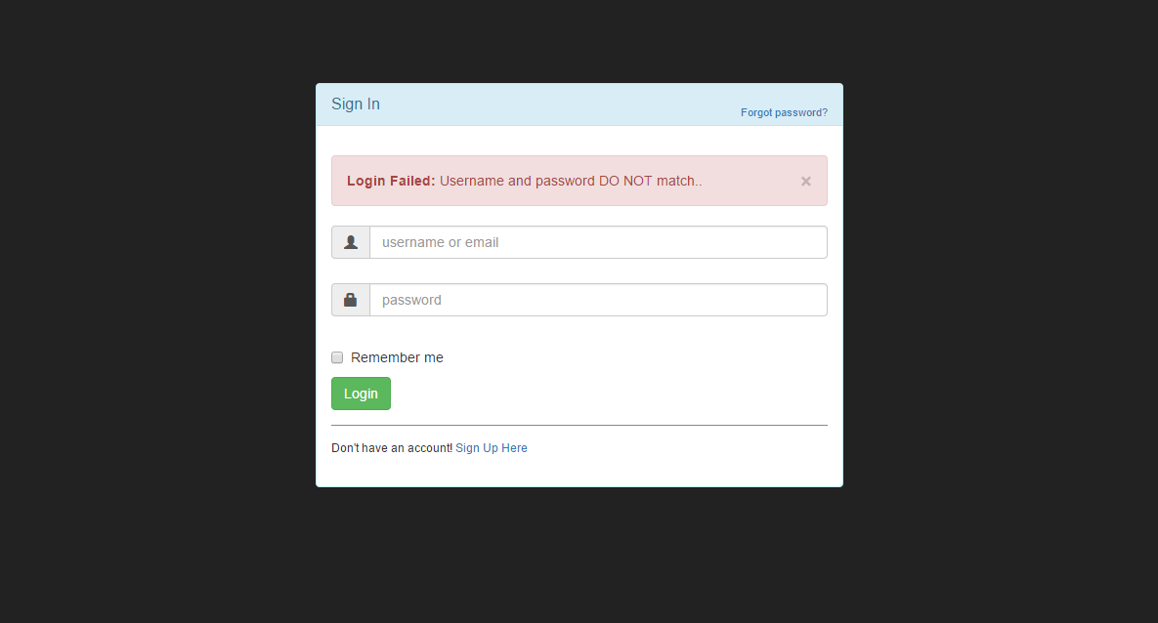

## Create Cookbook

Normal Course

1. The system displays a registered users homepage
2. The user clicks the button to “Create a Cookbook”
3. The system displays a dialog box for the cookbooks name
4. The user inputs the name of the cookbook and clicks OK
5. The system creates a new cookbook object and displays it to the users home page

Exceptions

Cancel Creation

1. The user selects cancel on the dialog box prompting for the cookbook name.
2. The user is returned to the user’s homepage and the cookbook is not created.

## Create Recipe

Normal Course

1. The system displays a registered users homepage



1. The user clicks the button to “Create a Recipe”

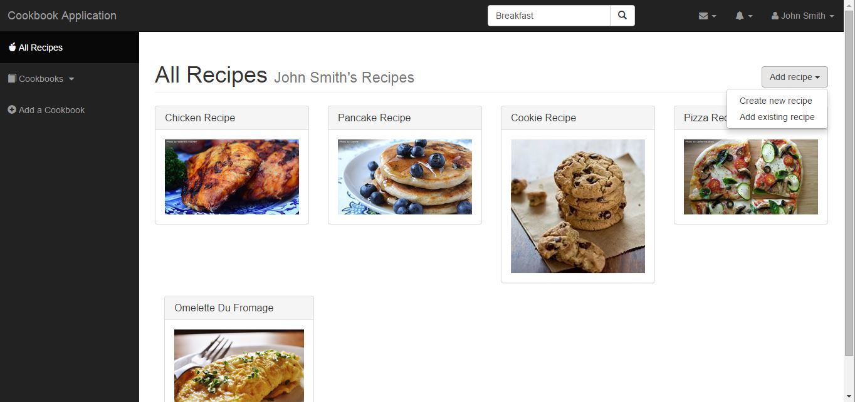

1. The system displays a form for the user to input the recipe name, ingredients, procedure, cook time, difficulty, creator, category, and cookbook (if applicable)

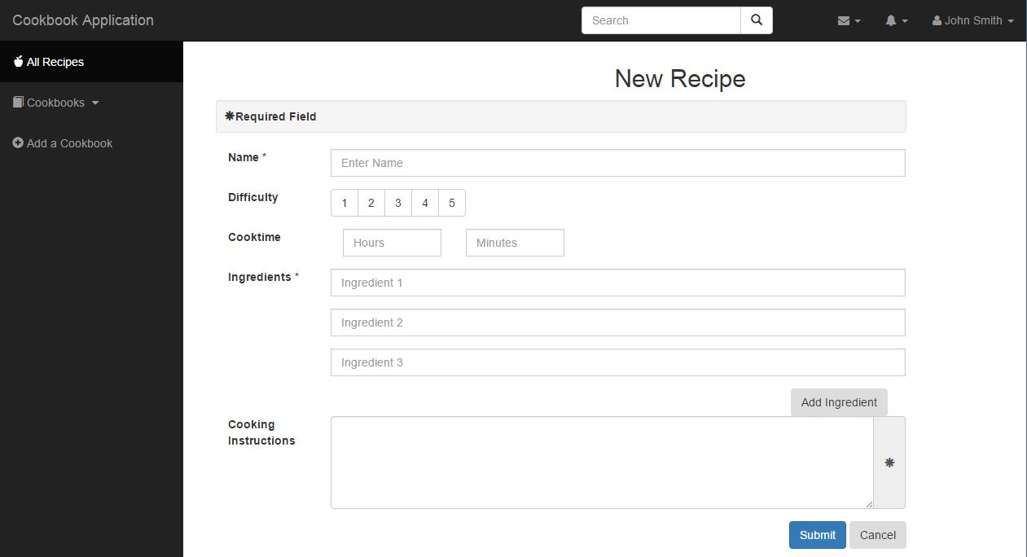

1. The user inputs the recipe information and clicks Submit
2. The system creates a new recipe object and displays the recipe object for the user

Exceptions

Cancel Creation

1. The user selects cancel on the recipe form.
2. The user is displayed the recipe.

## Create Ingredient

Normal Course

1. The system prompts the user that the ingredient does not exist and asks if the user wants to create it.
2. The user click OK to create the ingredient
3. The user enters new ingredient information
4. The system displays the updated recipe form with the added ingredient

Alternative Course

User Removes Added Ingredient

1. The user click to delete the new ingredient row.
2. The recipe form is displayed without the new ingredient row.

Exceptions

Cancel Creation

1. The user clicks cancel on the create ingredient dialog box
2. The system displays the recipe form

## Add Ingredients to Recipe

Normal Course

1. The system displays the recipe creation form
2. The user clicks the button to “Add Ingredients”
3. The system displays ingredient adding form
4. The user specifies the name of the ingredient
5. The system checks if the ingredient exists
   1. if the ingredient exists, the user selects the ingredient
   2. if the ingredient is not found, the system prompts the user to create the ingredient

6. The system prompts the user for the measurement and unit of the ingredient

7. The user enters a quantity followed by selecting a unit of measurement

8. The selects “Ok”

9. The system adds the ingredient to the recipe

10. The system prompts the user to keep adding ingredients.

11. The user selects “Yes” or “No”

1. if “Yes” the system repeats case
2. if “No” the system returns to recipe display

Exceptions

Cancel Ingredient

1. The user selects cancel button at any time during the adding process
2. The system does not add the ingredient

Ingredient Already Exists in Recipe

1. The user tries to add an ingredient that already exists in the recipe
2. The system alerts the user and prompts if they want to increase the quantity
3. The user cancels or enters new quantity
4. The system cancels the addition of the ingredient or updates the quantity

## Add Recipe to Cookbook

Normal Course

1. The system displays a recipe page to the user.
2. The user clicks the button to “Add Recipe to Cookbook”
3. The system displays a list of the user’s cookbooks to add the recipe to.
4. The user selects the cookbook to add the recipe and clicks Add
5. The system add the recipe to the cookbook
6. The system displays the recipe page of the recipe just added to the cookbook

Exceptions

Cookbook does not exist

1. The user does not have any cookbooks to choose.
2. The user is displayed the recipe with an error message.

## Modify Recipe

Normal Course

1. The system displays a registered users homepage
2. The user clicks the button to “Open Cookbook”.
3. The system displays the cookbooks recipes.
4. The user clicks a recipe.
5. The system displays the recipe selected by the user.
6. The user select to “Modify Recipe”.
7. The system displays the same recipe form displayed when creating a recipe, but the fields are pre-populated with the existing data. ← Recipe form with existing data
8. The user edits the recipe data and click “Submit”. ← Recipe form with modified data
9. The system updates the recipe in the database and displays the updated recipe page.

Alternative Course

Cancel Modification (deviates after step 7)

1. The user selects cancel on the recipe form
2. The user is returned to the recipe page and the recipe remains unmodified.

# For Administrator Users

## Modify Ingredients

Normal Course

1. The system displays an administrator users homepage
2. The user clicks the “Ingredients” tab to display all ingredients.
3. The user selects an ingredient and clicks “Modify”.
4. The system displays a dialog box with the ingredient selected by the user and the existing data pre-populated in the same dialog box as the create ingredient form.
5. The user edits the ingredient data and click “Submit”
6. The system updates the ingredient in the database and displays the updated page of ingredients.

Exceptions

Cancel Modification

1. The user selects cancel on the dialog box for modifying an ingredient
2. The user is returned to the user’s homepage and the ingredient remains the same.

## Modify Recipe

Normal Course

1. The system displays a registered users homepage
2. The user clicks the “Recipes” tab to display all recipes.
3. The user selects a recipe.
4. The system displays the recipe selected by the user
5. The user select to “Modify Recipe”
6. The system displays the same recipe form displayed when creating a recipe, but the fields are prepopulated with the existing data.
7. The user edits the recipe data and click “Submit”
8. The system updates the recipe in the database and displays the updated recipe page.

Alternative Course

Cancel modification (deviates after step 7)

1. The user selects cancel on the recipe form
2. The user is returned to the recipe page and the recipe remains unmodified.